Almely Ramos

Lynis Documentation

Linux Admin

11/18/19

(TO INSTALL YOU MUST BE ON ROOT OR USE THE SUDO COMMAND)

Step 1. Installing Lynis is fairly simple, just use the command:

“**yum install lynis**” and if you’re not on Root do “**sudo yum install lynis**”



Step 2: Wait for to install

***USING LYNIS***

Step 1: Depending on wat you want to use Lynis for your commands may vary, but for us, we are doing an audit on our systems. Use this command:

“**lynis audit system**”



Step 2: Wait for the Audit to finish

Step 3: When the audit finish, use these commands to find anything that’s wrong you’re your system setup.

To find any Warnings in the audit use command:

“**grep Warning /var/log/lynis.log**”

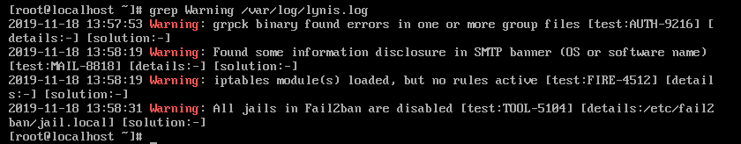

For Suggestions use command:

“**grep Suggestion /var/log/lynis.log**”

Use these 2 commands to make improvements to your servers.